3.1. PROGRAM ANALYSIS
By Elvis Avduli, E22001

Description
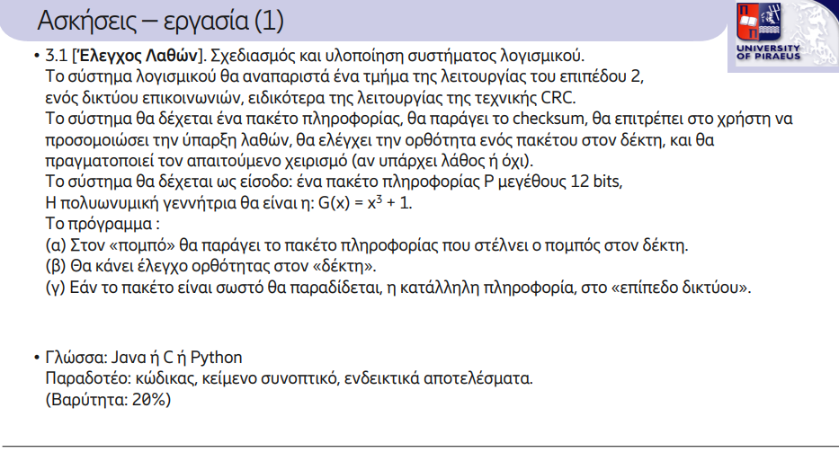
Overview
This program simulates Cyclic Redundancy Check (CRC) error detection in a communication system. It includes functions to calculate the CRC remainder, simulate errors in transmitted data, and verify received data for errors. The program uses a generator polynomial G(x) = x^3 + 1 represented as the binary string "1001".

Inputs
The program requires three main inputs:
First, a Data Packet, which is a 12-bit binary string provided by the user. Validity checks ensure the input is exactly 12 bits long and contains only '0' or '1'. Any invalid input prompts the user to re-enter the data packet until a valid one is provided.
Second, the Generator Polynomial is hardcoded as "1001". This represents the polynomial G(x) = x^3 + 1 used for the CRC calculations.
Lastly, an optional Error Position allows the simulation of a transmission error. The position is specified as a zero-based index and determines which bit in the transmitted packet will be flipped to simulate an error.

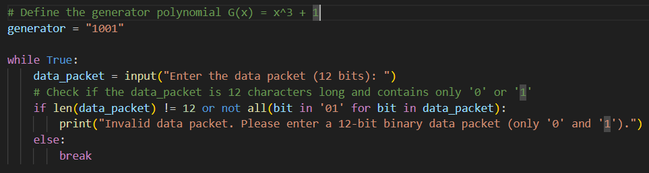
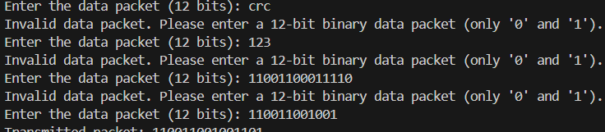

Program Workflow
The program follows these steps:
First, Input Validation ensures that the user enters a valid 12-bit binary data packet. If the input is invalid, the program repeatedly prompts the user for a new input until a valid packet is provided.
Next, on the Transmitter Side, the program calculates the CRC remainder using the crc_remainder function. This remainder is appended to the original data packet to create the transmitted packet, which is then displayed.
Optionally, Error Simulation allows introducing an error at a specified bit position in the transmitted packet using the simulate_error function. This step is commented out by default but can be enabled for testing purposes.
On the Receiver Side, the program calculates the remainder of the received packet using the crc_remainder function. It compares the received remainder with the expected remainder "000". If they match, the program confirms that no error occurred. If they differ, it detects an error. Based on this, the program either accepts and passes the data to the network layer or rejects it.

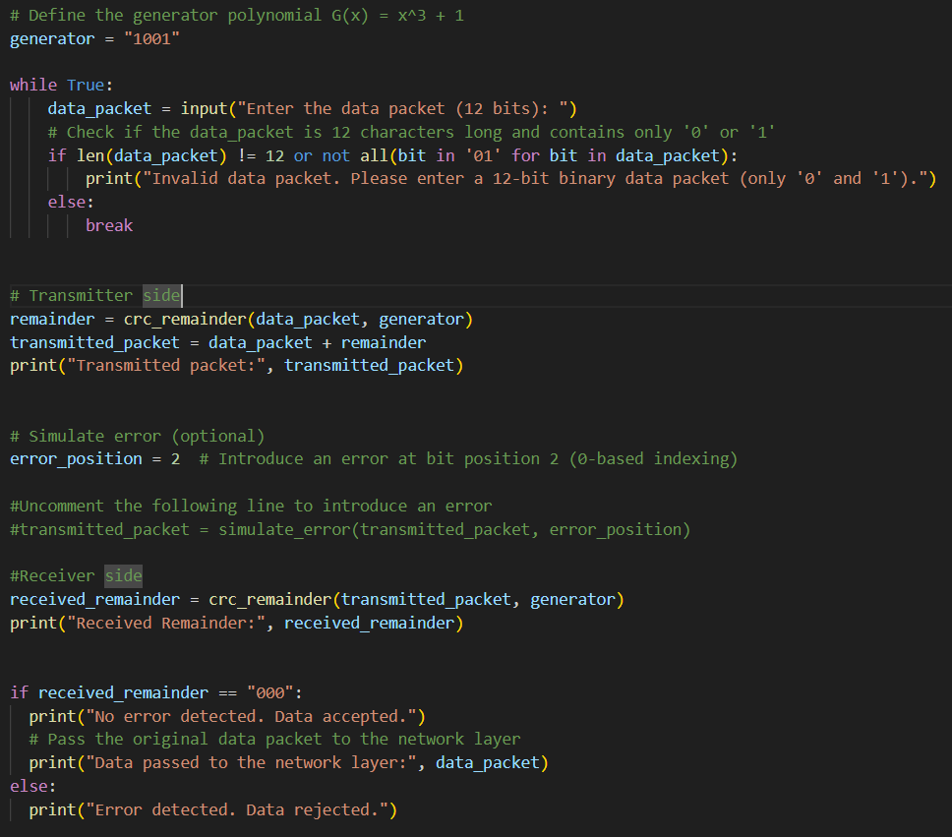

Functions
1. crc_remainder(data, generator)
This function calculates the CRC remainder for a given data packet and generator polynomial.
The function takes two inputs: data, a binary string representing the data packet, and generator, the binary string representing the generator polynomial. It appends zeros to the data, performs bitwise division using XOR operations, and extracts the remainder from the modified data. The function returns the remainder as a binary string.
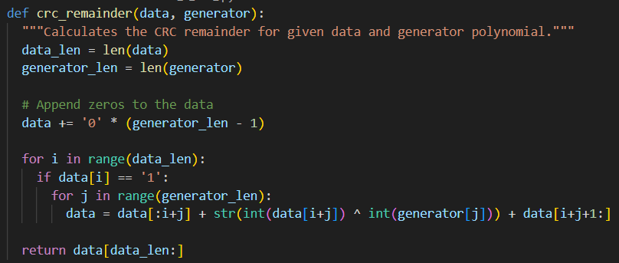

2. simulate_error(data, position)
This function simulates an error in the data packet by flipping the bit at a specified position.
The inputs are data, a binary string representing the data packet, and position, the integer index of the bit to be flipped. The function converts the string to a mutable list, flips the bit, and converts it back to a string. The output is the data packet with the simulated error.
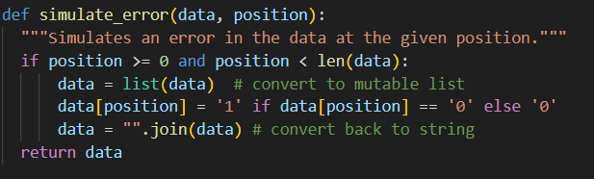

Outputs:

With simulated error:
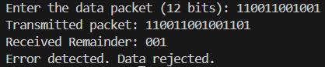
Without simulated error:
